**Using SE84 to find BADI**

Find package for a T-code. Go to SE93, provide t-code name (VA01), display.

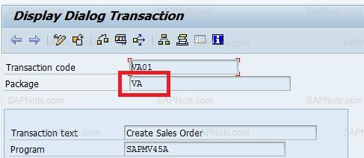

Go to SE84, expand enhancements, expand Business Add-ins and select definition.

Provide package name and execute, you will find list of BADI`s.

